

Statutory Public Meeting & Recommendation Report
Community Planning Department - PO Box 5013, 426 Brant St., Burlington, ON L7R 3Z6 | burlington.ca

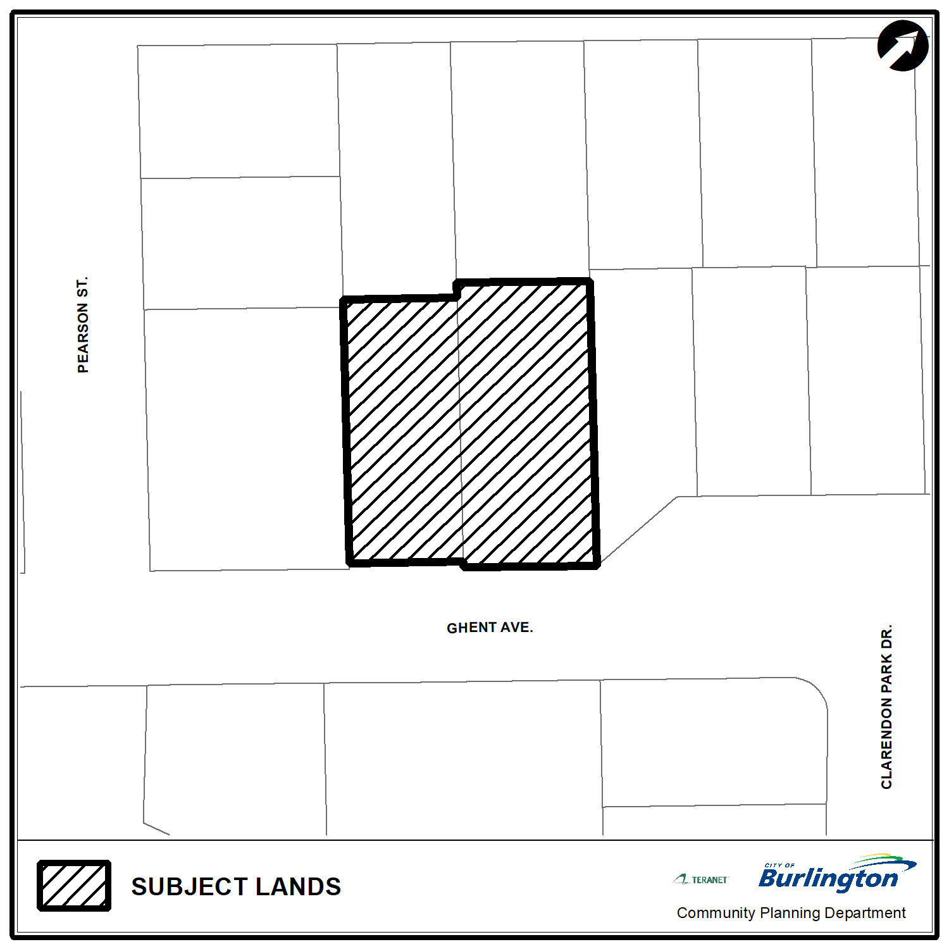
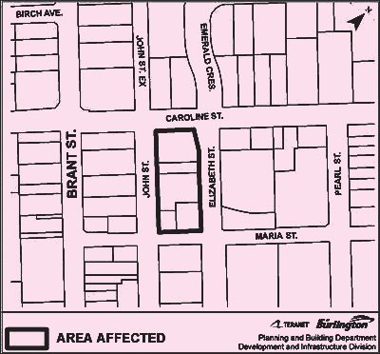
What is Proposed?
The subject proposal intends to construct two, three-storey buildings that will provide a total of 12 purpose built rental units and will include an affordable or attainable housing component. The proposed walk-up apartment would provide a density of 70 units per hectare and would offer a minimum of 355 m2 of amenity space and 57 m2 of privacy area. The proposed walk-up apartment style buildings would include 16 parking spaces with one (1) of those being accessible. A fully enclosed accessory structure for the storage of waste that is designed to complement the design of the residential buildings is included in the development concept.

Planning Application submitted by:
Corbett Land Strategies c/o Alicia Monteith

Site Address - Ward 2
2169-2175 Ghent Avenue
Planner on File
Name: Benjamin Kissner
Mailing Address: 426 Brant St., Burlington, ON L7R 3Z6 Email: Benjamin.kissner@burlington.ca
Phone: 905-335-7600, ext. 7913
File: 505-07/24 & 520-14/24
burlington.ca/2169ghent

Statutory Public Meeting Information
You are invited to attend a Public Meeting to consider the recommendation report concerning the above mentioned application.
City staff have reviewed the applications along with the comments from the public and technical agencies received to date. Staff will be providing a recommendation on the amendments to the City’s Committee of the Whole.
This meeting will be held using a hybrid model, allowing members of Council, City staff and the public the option of participating remotely or in person at Burlington City Hall, 426 Brant St. This meeting will take place on:

Meeting Date – February 11th, 2024
Time: 9:30 a.m.
Location: Virtual Meeting held in hybrid model
(See next page for Access Instructions)

\
Looking for more information?
You can access the City of Burlington’s website for more information about the application. The application has its own webpage which contains additional material, including supporting studies that have been submitted by the applicant. This webpage will be updated throughout the process.
To access the webpage for this application please go to: burlington.ca/2169ghent
To learn more about the planning process visit: burlington.ca/planningprocess
If you wish to be notified of the decision on the proposed Zoning By-law amendment, you must make a written request to Legislative Services at clerks@burlington.ca

Options for Participating in the Statutory Public Meeting
How to Obtain the Staff Report:
The staff recommendation report which contains a discussion and review of the applications, will be available for public review on Friday, January 31st, 2025. The purpose of the report is to update all members of Council about the development proposal and provide a recommendation to Council on the application. The report will be available on the City’s website at www.burlington.ca/calendar by searching for the meeting date for the Committee of the Whole. If you require a hard-copy of the report, please email Legislative Services at clerks@burlington.ca to arrange pick-up.
Speaking at the Statutory Public Meeting as a Delegation:
To speak at the Public Meeting, there are two options:
- Pre-register to speak by noon the Friday before the meeting is to be held. You can pre-register in one of the following ways:
  - complete the online delegation request form at www.burlington.ca/delegation;
  - submit a written request by email to Legislative Services at clerks@burlington.ca, or
  - phone 905-335-7600, ext. 7481.
- Register during the Public Meeting.
  - If you are attending the meeting virtually, you can register to speak by emailing clerks@burlington.ca, as noted in the ticker tape that will be scrolling along the bottom of the live stream webcast of the meeting with registration information.
  - If you are attending the meeting in person, you can register to speak during the meeting by following instructions provided at the meeting.
Speakers are limited to a maximum of 10 minutes each and are webcasted online. If you have presentation materials, they must be submitted to Legislative Services at clerks@burlington.ca no later than noon, the Friday before the meeting to allow for their distribution and review by all members of the Committee. Please note the content of all submissions is considered public and will be posted to the City’s website.

To Watch the Public Meeting Online:
Visit the City’s website at www.burlington.ca/calendar by searching for the meeting date for the Committee of the Whole and clicking the ‘Watch Video’ link. Click on the link to view the virtual statutory Public Meeting in progress at the time listed on this Notice.

The live webcast can also be accessed on the City’s website at www.burlington.ca/calendar by searching for the meeting date for the Community Planning, Regulation and Mobility Committee and clicking the ‘Video - Live’ link.

The Official Plan is the City’s blueprint for the future. It includes policies to guide planning decisions made by the City. The Official Plan must be consistent with provincial and regional plans and policies.
Learn more at burlington.ca/newop

The Zoning By-law contains specific rules about how each property should develop and includes details like permitted uses, maximum heights, building setbacks, and lot coverage, etc.
Learn more at burlington.ca/zoning

Legal Notices: Personal information is collected under the authority of the Planning Act, R.S.O. 1990, c. P. 13 and may be contained in an Appendix of a staff report, published in the meeting agenda, delegation list and/or the minutes of the public meeting and made part of the public record.

The City collects this information in order to make informed decisions on the relevant issues and to notify interested parties of Council’s decisions. It may also be used to serve notice of an Ontario Land Tribunal Hearing. Names and addresses contained in submitted letters and other information will be available to the public, unless the individual expressly requests the City to remove their personal information. The disclosure of this information is governed by the Municipal Freedom of Information and Protection of Privacy Act, R.S.O. 1990, c.M. 56.

If a specified person or public body as defined under the Planning Act or the registered owner of any land to which the plan or by-law would apply would otherwise have an ability to appeal the decision of the Council of the City of Burlington to the Ontario Land Tribunal, but the specified person or public body as defined under the Planning Act or the registered owner of any land to which the plan or by-law would apply does not make oral submissions at a public meeting or make written submissions to the City of Burlington before the proposed Official Plan Amendment is adopted or Zoning By-law Amendment is passed, the specified person or public body as defined under the Planning Act or the registered owner of any land to which the plan would apply is not entitled to appeal the decision to adopt the proposed Official Plan Amendment or the by-law.

If a person or public body does not make oral submissions at a public meeting or make written submissions to the City of Burlington before the proposed official plan amendment is adopted and/or the by-law is passed, the person or public body may not be added as a party to the hearing of an appeal before the Ontario Land Tribunal unless, in the opinion of the Tribunal, there are reasonable grounds to do so.

